Mark Mekosh

PHYS510

Homework #4

1. Code is in “Molecular_Dynamics2.jl”

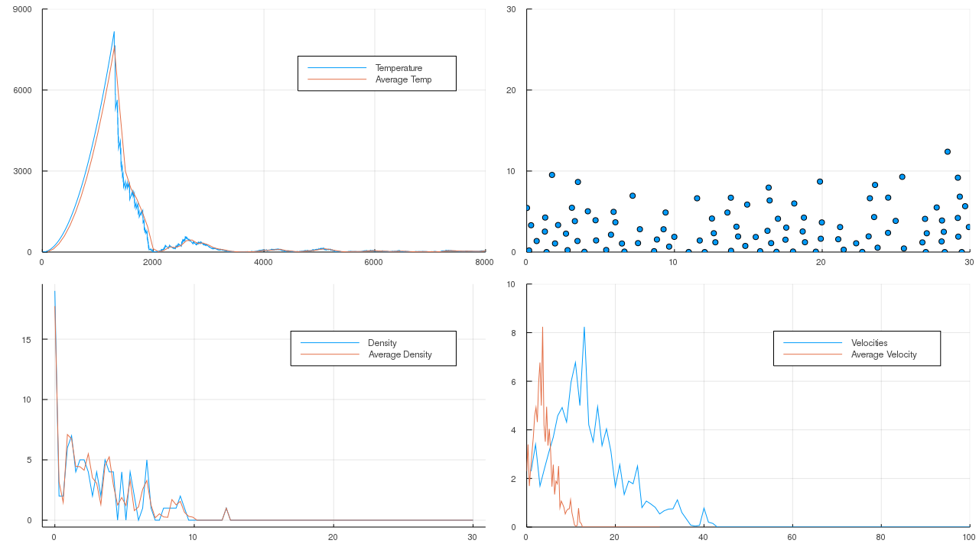

This plot shows the temperature at each time step, as well as the average temperature over intervals of 100 time steps. It also shows the density as a function of time at the last time step in blue, as well as the average density over 100 time steps. The top right plot shows the configuration of the particles at the end of the 8000 time steps. The bottom right plot shows the momentum distribution at the end of the simulation, as well as the average momentum distribution over 100 time steps. In this case since the particles all have mass 1, the momentum is the velocity.

1. Temperature and average temperature can be seen in this plot (“Final_Simulation_8kSteps.png”) as well as “Average_Temp.png” and “Molecular_Simulation.gif”
2. Different configurations are shown in “Adjustion_Simulation_Box.gif”, “Adjusted_Simulation_Triangle.gif”, and “Molecular_Simulation_20kSteps.gif”
3. When g = 0 the particles separate into 4 groups that stick together by the internal forces between the particles, eventually two of these groups collide and stick together. With g = 0.1 the particles again split into 4 groups, but eventually all come together in a big lump, like water beading up.
4. The general shape of the particle density plot (“rho_plot.png”) matches what’s shown in the average density plot
5. The general shape of the momentum distribution plot (“momentum_plot.png”) is similar to the plot of the average velocity.

2. Code is in “Heat_Equation.jl”

This lecture and question left me confused. I think I managed to implement a gaussian elimination solver. I tried to work things out on my own, but I didn’t seem to get anywhere, and I took too much time on the first question.